CET 753
Lab Completion Sheet
Chapter 7

Name ____________________________

# | Page | Chapter/Activity | Status | Description
44 | 269 | 7-1 |  | Viewing the Active Partition

Screen Shot(s) | Documentation
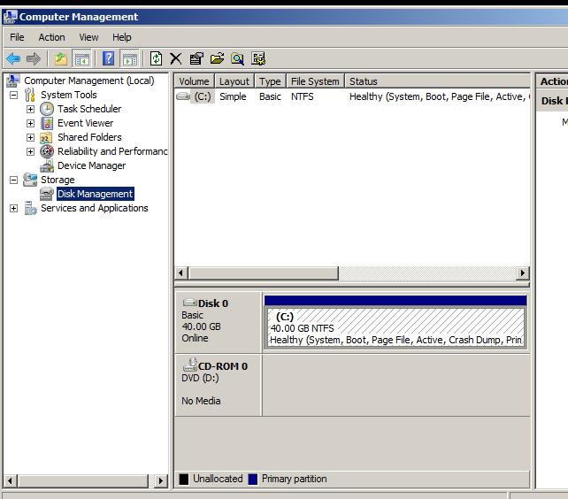

# | Page | Chapter/Activity | Status | Description
45 | 270 | 7-2 |  | Customize the MMC to Access Disk Management Tools

Screen Shot(s) | Documentation
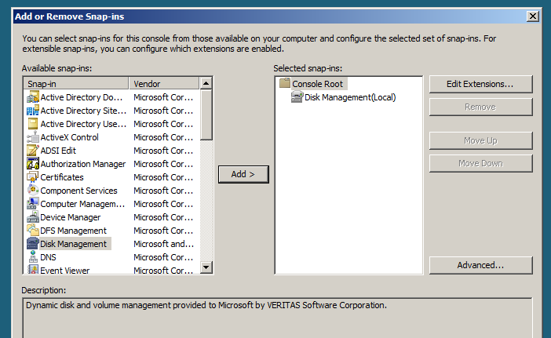

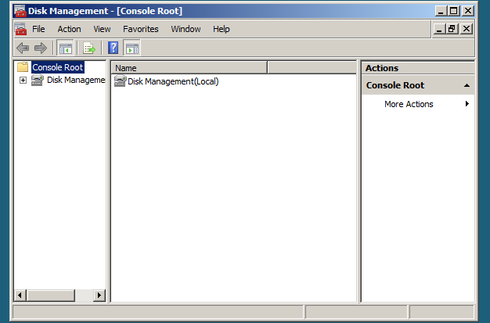

# | Page | Chapter/Activity | Status | Description
46 | 274 | 7-3 |  | Creating a Simple Volume
Special Note: Prior to completing this you will need to first right click on your C:\ volume and first choose to shrink it. Simply select the defaults and it will then after a short wait provide unallocated space for you to create your simple volume within.

Screen Shot(s) | Documentation
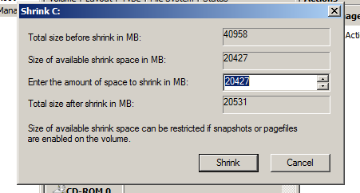

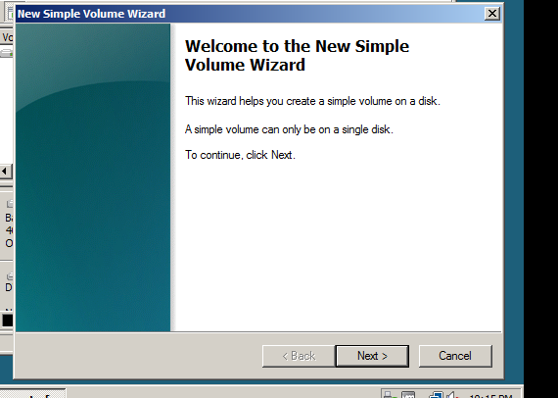

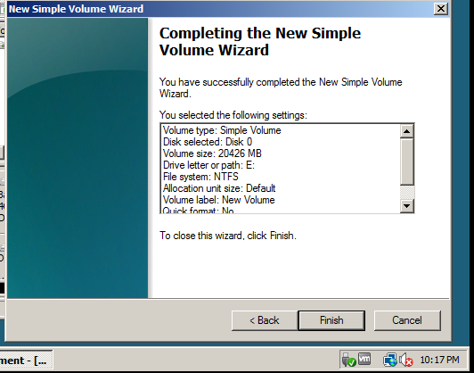

# | Page | Chapter/Activity | Status | Description
47 | 276 | 7-4 |  | Converting a Basic Disk

Screen Shot(s) | Documentation
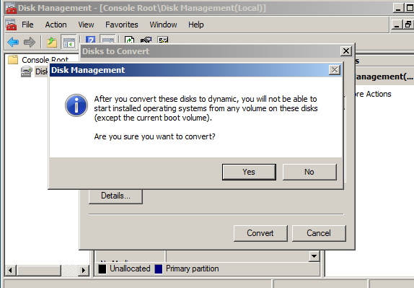

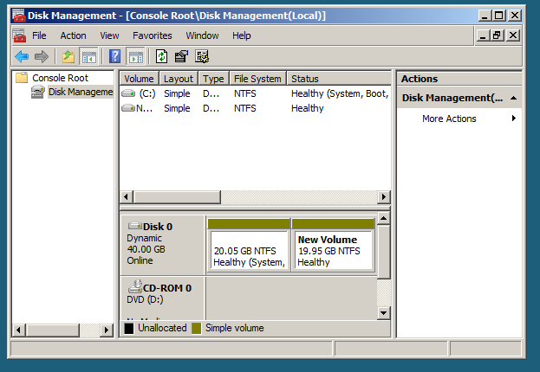

# | Page | Chapter/Activity | Status | Description
48 | 277 | 7-5 |  | Configuring a Mounted Drive
Special Note: You will stop at Step 9 as you do not have drive to mount
Screen Shot(s) | Documentation
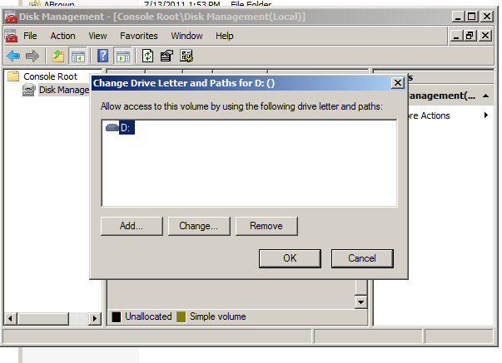

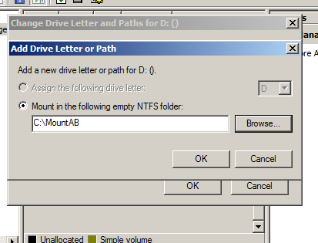

# | Page | Chapter/Activity | Status | Description
49 | 280 | 7-7 |  | Using Disk Check

Screen Shot(s) | Documentation
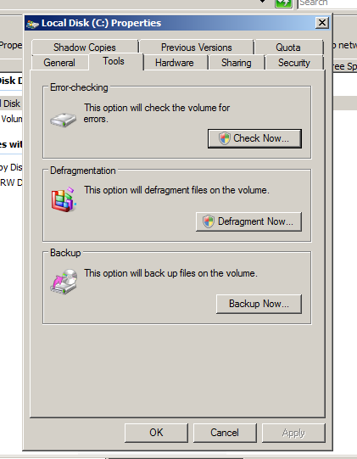

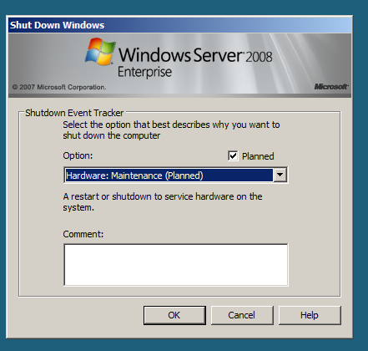

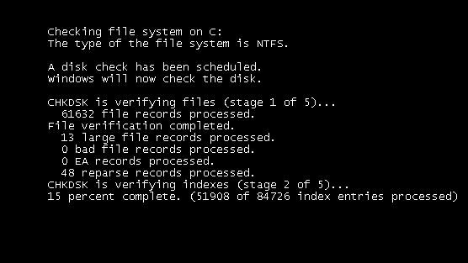

# | Page | Chapter/Activity | Status | Description
50 | 281 | 7-8 |  | Using chkdsk from the Command Line

Screen Shot(s) | Documentation
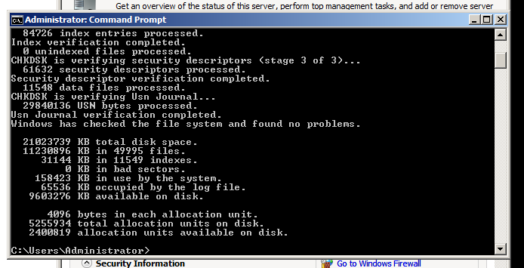

# | Page | Chapter/Activity | Status | Description
51 | 291 | 7-10 |  | Backing Up a Server

Screen Shot(s) | Documentation
